Assignment 32.3

Problem Statement:

● Write a Java client API to perform following operations:

● Use HBaseAdmin class and create the table named company with one column family name details.

● Create the method name insert and use put class to insert records to company table.

**Create Table Operation:**

If any operation is to be performed on any data, file or table, first that particular content should exist in the Filesystem or in the Database

Therefore, to perform different operations on a table in HBase, we need a table to be created. To create a table, we need to create an instance of HBaseAdmin and then ask it to create the table with a name and with at least one column family name in it.

Here in this program, I am creating a table named ***Comapany*** with one column family named ***details***

Create HBase table program

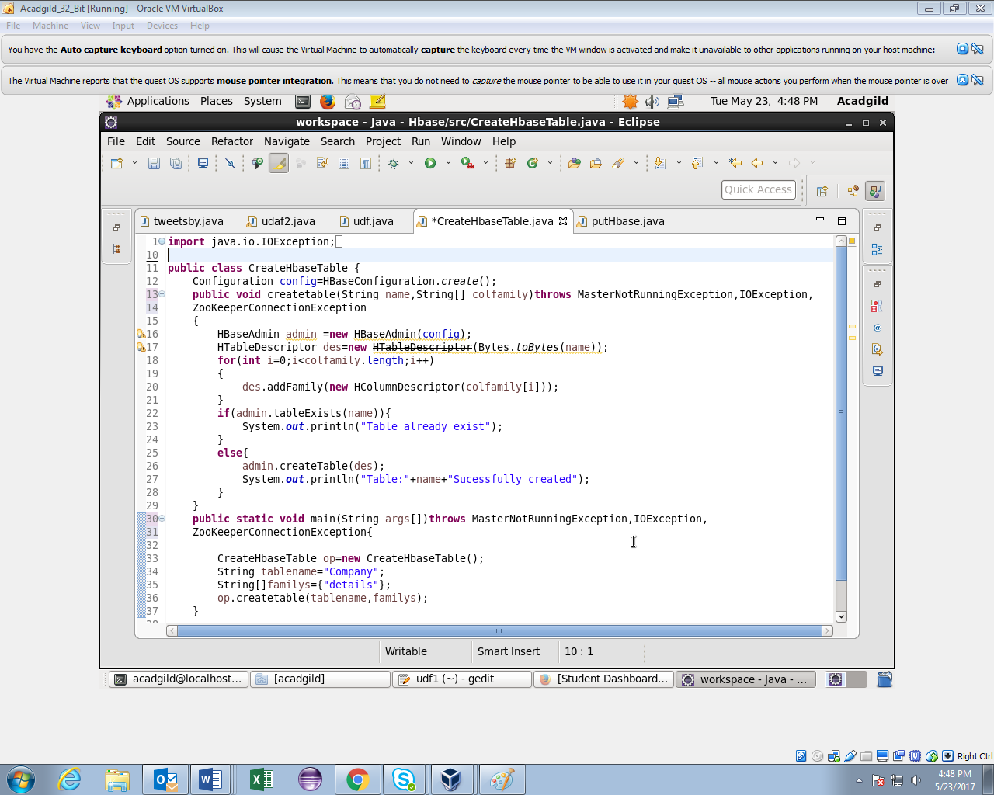

After executing the ***CreateHbaseTable*** Java API program, we can see in the below image a message is displayed, stating Table named ***Company*** has been successfully created.

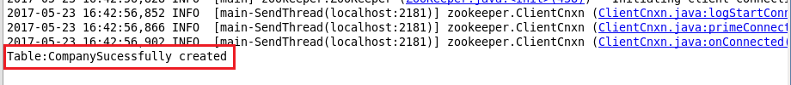

Put HBase program

**Put Operation:**

We can use put class for performing inserting operation rows in a HBase table.

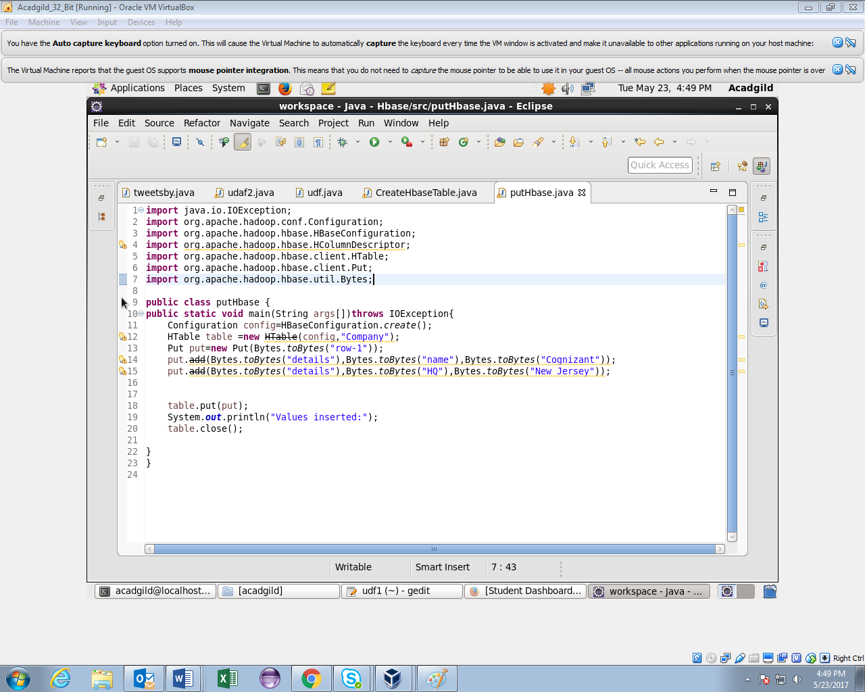

**putHbase Table Output:**

After executing the above ***putHbase*** Java API program, we can observe in the below image that a successful message is thrown stating ***values inserted*** .

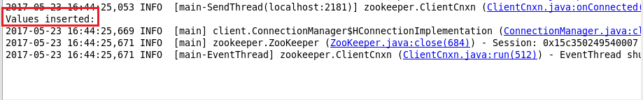

Now, we can check whether the table ***Company*** has been successfully created or not in the HBase default database, using ***list*** command in the HBase terminal.

Thus, by using scan command in HBase terminal with the table name, we can see the table values of column family ***details*** as ***Cognizant and New Jersey*** respectively.

